TO: CIO  
FROM: Team 5  
SUBJECT: RE: URL Blocking

The following URLs have been blocked as requested:

Twitter.com  
Youtube.com  
Facebook.com

Example of the new rule working in Figure 4.

This is done via Palo Alto’s URL blocking native tool.   
Instructions:

1. Login to Palo Alto
2. Objects → Security Profiles → URL Filtering (Figure 1)
3. Either create a new rule or clone a rule
4. Name the object appropriately
5. Add the URLs needed to be blocked. Do not add http(s).
6. Change action to block. Click OK
7. Go to Policies → Security → Choose proper firewall rule
   1. Most likely LAN2External
8. Edit policy →Action → Change Profile Type to Profile (Figure 2)
9. Pick URL Filtering to the named URL Filtering Objected from above.
10. Security Policy will have an icon in the profile column (Figure 3)
11. Commit change

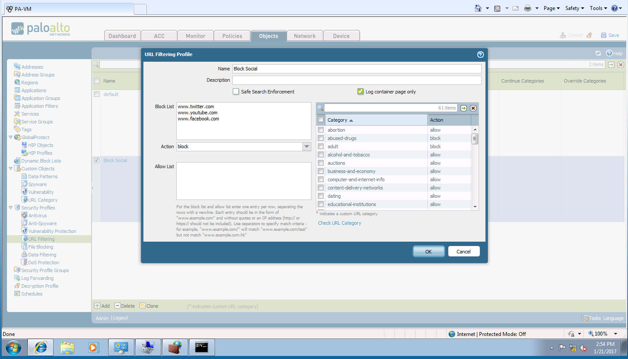

Figure

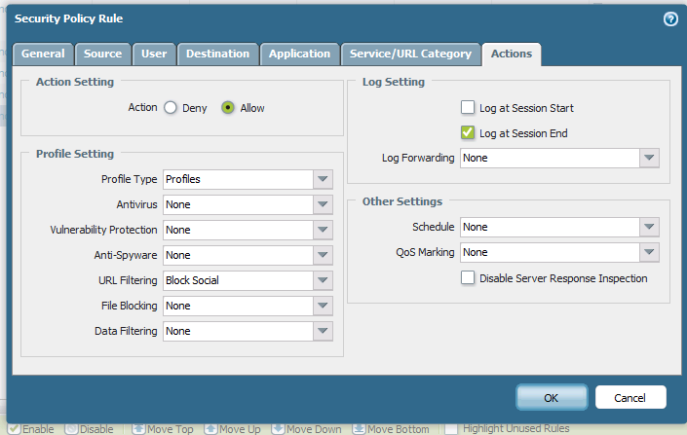

Figure

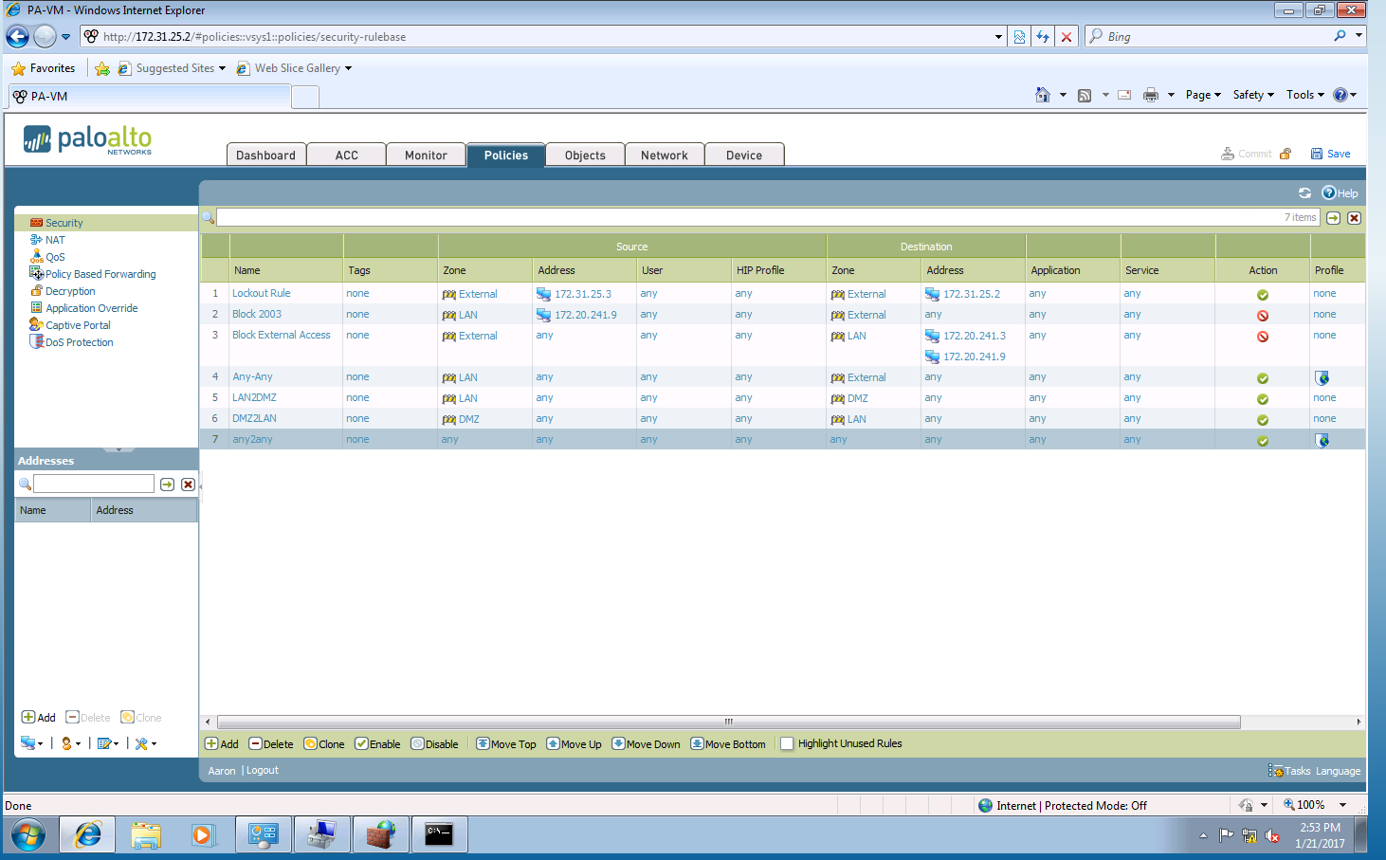

Figure

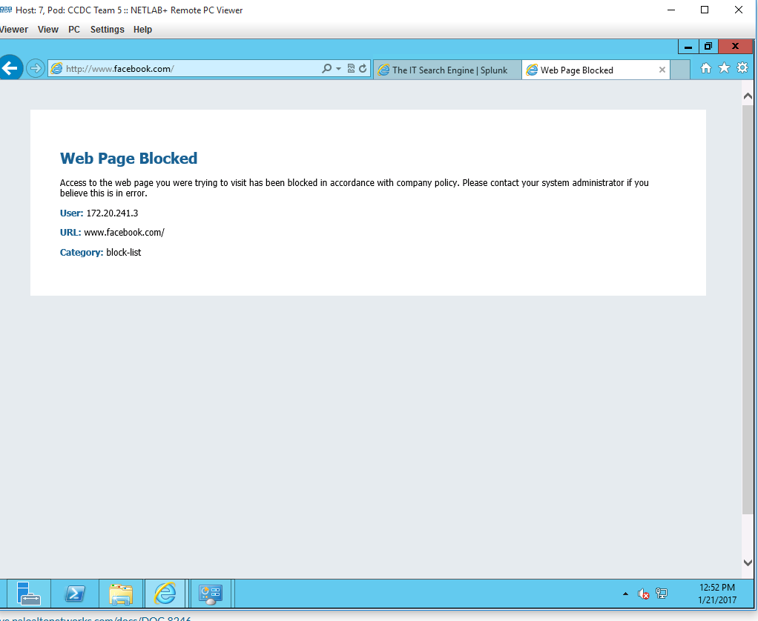

Figure